Customer Orders Analysis
Problem Statement
You are working as a Data Analyst for an e-commerce company.
Your task is to analyze customer purchases, orders, and payments using SQL JOIN operations.
You are given 3 tables:
- customers
- orders
- payments

Write SQL queries to answer the business questions below. Database Schema customers
Column Name Data Type customer_id INT (PK) customer_name VARCHAR
city VARCHAR
orders
Column Name Data Type order_id INT (PK)
customer_id INT order_date DATE Column Name Data Type
amount DECIMAL
payments Column Name Data Type payment_id INT (PK) order_id INT
payment_status VARCHAR
Sample Data
CREATE TABLE customers ( customer_id INT PRIMARY KEY, customer_name VARCHAR(100), city VARCHAR(50)
);
INSERT INTO customers VALUES
(1, 'Amit', 'Bangalore'),
(2, 'Sneha', 'Mumbai'),
(3, 'Rahul', 'Delhi'),
(4, 'Priya', 'Chennai');
CREATE TABLE orders ( order_id INT PRIMARY KEY,
customer_id INT, order_date DATE,
amount DECIMAL(10,2)
);
INSERT INTO orders VALUES
(101, 1, '2024-01-10', 500),
(102, 1, '2024-02-15', 700),
(103, 2, '2024-03-01', 300),
(104, 5, '2024-03-05', 900);
CREATE TABLE payments ( payment_id INT PRIMARY KEY, order_id INT, payment_status VARCHAR(20)
);
INSERT INTO payments VALUES
(1, 101, 'Completed'), (2, 102, 'Pending'),
(3, 103, 'Completed');
Tasks
Task 1: Customer Orders Write a query to display:
- customer_name
- order_id
- amount

Include only customers who placed orders. 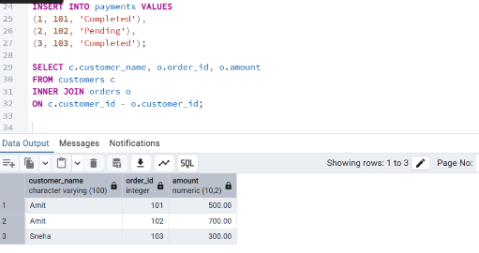
Task 2: All Customers
Write a query to display:
- all customers
- their order_id (if any)

Customers without orders should still appear.
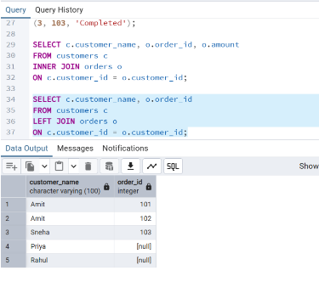
Task 3: Invalid Orders Write a query to find:
- orders that do NOT have a matching customer
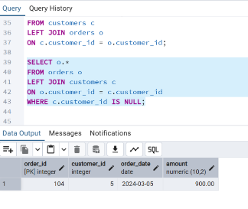
Task 4: Order Payment Status
Write a query to display:
- customer_name
- order_id
- payment_status

Include all orders, even if payment is missing.
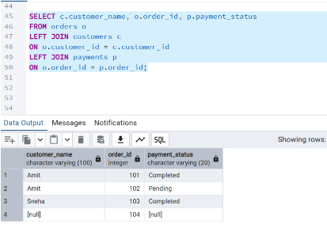
Task 5: Customers Without Orders
Find customers who have never placed an order.
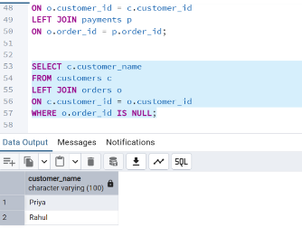
Task 6: Orders Without Payment
Find all orders that do not have a payment record.
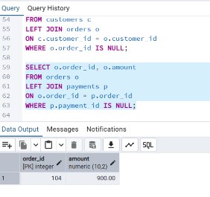
Task 7: Total Spending
Write a query to calculate:
• total amount spent by each customer
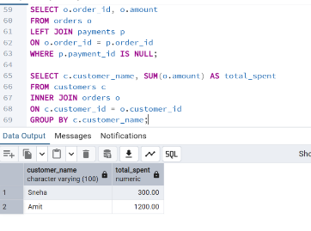
Task 8: Fully Paid Customers
Find customers whose all orders are marked as 'Completed'.
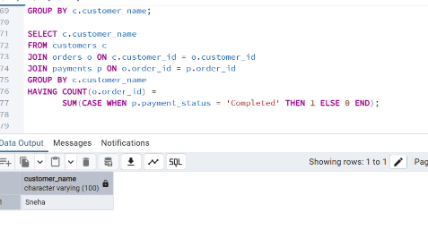
Task 9: Highest Order Per Customer
Display:
- customer_name
- highest order amount
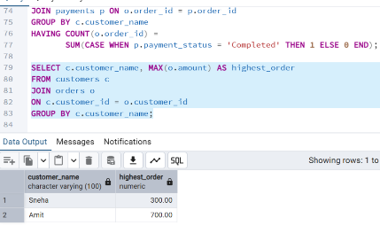
Task 10: Top Customers
Find top 2 customers based on total spending.
Rules
  - Use appropriate JOIN types: INNER JOIN o LEFT JOIN
  - RIGHT JOIN

  - Avoid subqueries unless necessary
  - Use GROUP BY where required
  - Write clean and readable SQL
  - 